SPALDING COMMUNITY SERVICES DISTRICT
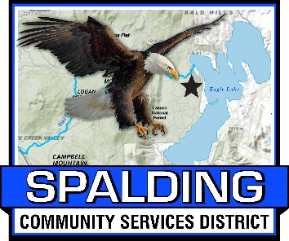
BOARD OF DIRECTORS
Members of the Board
Mike Arnold, Board Chair
Larry Doss, Board Vice Chair
Randall Aubrey, Director
Ed Lawson, Director
Ted Thomas, Director

MEETING AGENDA
March 17, 2023
3:00 PM
Meeting Location
Eagle Lake Community Center
502-907 Mahogany Way, Susanville, CA 96130
72060 W. Menlo Avenue, Fresno CA 93723 (Telephonic Location)
561 Swain Avenue, Sebastopol, CA 95472 (Telephonic Location)
530-825-3258

Welcome to the SCSD Board Meeting - Please sign in

Welcome to the SCSD Board Meeting! Members of the public may provide public comment on any item on the Board’s agenda, or on any item that is within the subject matter jurisdiction of this Board. Public comments are limited to five (5) minutes (unless the Chairman of the Board grants a longer period of time).

CALL TO ORDER
ROLL CALL
____ Mike Arnold ____ Randy Aubrey ____ Larry Doss
____ Ed Lawson ____ Ted Thomas

- PLEDGE OF ALLEGIANCE

- PUBLIC COMMENT - Members of the public may provide public comment on any item on the Board’s agenda, or on any item that is within the subject matter jurisdiction of this Board. Public comments are limited to five (5) minutes (unless the Chairman of the Board grants a longer period of time).

- APPROVAL OF THE AGENDA

- APPROVAL OF MINUTES

- Submitted for approval are the minutes from February 17, 2022 Board of Directors Meeting.

- FIRE CHIEF REPORT TO BOARD

  - Resolution 2023-04: A Resolution Of The Board Of Directors Of The Spalding Community Services District Revoking Resolution 2023-03, Appropriating Funds, And Approving The Acquisition Of A 2023 Mack Fire Water Truck.

- GENERAL MANAGER REPORT TO BOARD

  - February, 2023 Financial Reports

- SEWER DEPARTMENT REPORT

  - See attached report

- BOARD MEMBER REPORTS / BOARD MEMBER COMMENTS

- NEW BUSINESS

No New Business

- CONTINUING BUSINESS

  - SCSD Sewer Rate Study from NorthStar – Updated Contract Attached

  - Update on Marina “Dredging” Permits/Project – No new data

- ADJOURN

NEXT REGULAR MEETING IS SCHEDULED FOR APRIL 21, 2023 AT 3:00 PM

