Spalding Community Services District
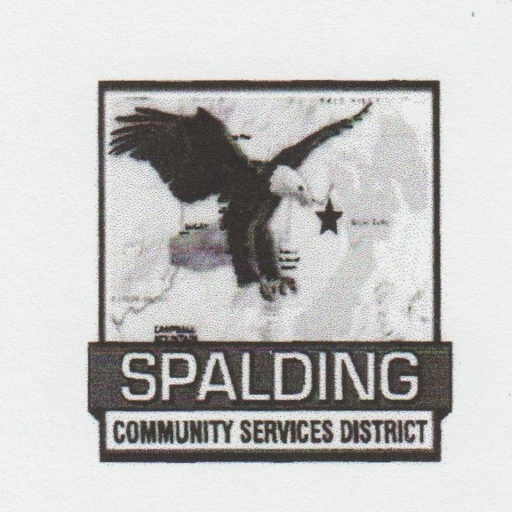  Eagle Lake Community Center  502-907 Mahogany Way  Susanville, CA 96130 | Directors: Kathy Claytor: Chair Ellen Stallings: Vice Chair Jerald Oliver  Scott Hagen  Vacancy | Staff:  Mike Garcia: General Manager  Kelly Handy: Office Manager  Frank Muse: Volunteer Fire Chief  Brad Mallory: Sewer Technician  Stacey Hamm: Office Assistant

Meeting ID: 874 8067 6801
Passcode: 502907
Link:
https://us06web.zoom.us/j/87480676801?pwd=XJwKL6GU6bwmJd2LrXt7ltZEseZIFD.1
Phone Call In: (646) 568-7788
Meeting ID: 874 8067 6801#
Passcode: 502907#

SPECIAL MEETING

The Spalding Community Services District welcomes, appreciates and encourages participation in the District’s Board Meetings. The Board requests that you limit your presentation or comment to five minutes per person so all who wish to participate may have the opportunity to do so, at the discretion of the Board Chair. The Board reserves the right to reasonably limit the total time for public comment on any particular noticed agenda item as it may deem necessary. Online and telephonic access does not guarantee the public the ability to observe the meeting in the event there is a disruption or connectivity issues that affect broadcasting. All remote attendees are expected to remain muted except for the time reserved for public comment to avoid any potential disruption of the meeting and to preserve appropriate decorum. Members of the public who want to be assured that they have the ability to observe the meeting and make comment during the meeting, should attend the meeting in person.

Agenda
Board of Directors
Special Board Meeting
1:00 PM
April 30, 2026
Note For Public Comments
Members of the Public may provide public comments on any item on the Board’s agenda or on any item that is within the subject matter jurisdiction of this Board. Public comments are limited to five (5) minutes (unless the chairperson of the Board specifies a different period of time). Comments by members of the public on an item that appears on the agenda will only be allowed during consideration of the item by the Board.

- Call to Order – Kathy Claytor

- Roll Call - Mike Garcia
Kathy Claytor _____ Ellen Stallings _____ Jerald Oliver _____ Scott Hagen _____

- Agenda Approval – Kathy Claytor
ACTION ITEM
Vote to approve current agenda
Supporting Documents: Special Meeting Agenda April 30, 2026
Board Discussion
Public Comment
Motion to Approve the Agenda
Board Vote: Kathy Claytor _____ Ellen Stallings _____ Jerald Oliver _____ Scott Hagen ____

- Ratification Standing Sewer Committee - Mike Garcia
ACTION ITEM
The District Motioned and Voted to create the Standing Sewer Committee in the March Meeting. We need to Move and Vote in the Board Member/s that will be sitting on the committee. We also need to Vote on the day and time the committee will meet.
Supporting Documents: NA
Board Discussion
Public Comment
Motion for Board Representation:
Board Vote: Kathy Claytor _____ Ellen Stallings _____ Jerald Oliver _____ Scott Hagen ____
Tabled ______
Motion on Meeting Day and Time:
Board Vote: Kathy Claytor _____ Ellen Stallings _____ Jerald Oliver _____ Scott Hagen ____
Tabled ______

- Ratification Standing Recreation Committee – Mike Garcia
ACTION ITEM
The District Motioned and Voted to create the Standing Recreation Committee in the March Meeting. We need to Move and Vote in the Board Member/s that will be sitting on the committee. We also need to Vote on the day and time the committee will meet.
Supporting Documents: NA
Board Discussion
Public Comment
Motion for Board Representation:
Board Vote: Kathy Claytor _____ Ellen Stallings _____ Jerald Oliver _____ Scott Hagen ____
Tabled ______
Motion on Meeting Day and Time:
Board Vote: Kathy Claytor _____ Ellen Stallings _____ Jerald Oliver _____ Scott Hagen ____
Tabled ______

- Ratification Standing Budget Committee – Mike Garcia
ACTION ITEM
The District Motioned and Voted to create the Standing Budget Committee in the April Meeting. We need to Move and Vote in the Board Member/s that will be sitting on the committee. We also need to Vote on the day and time the committee will meet.
Supporting Documents: NA
Board Discussion
Public Comment
Motion for Board Representation:
Board Vote: Kathy Claytor _____ Ellen Stallings _____ Jerald Oliver _____ Scott Hagen ____
Tabled ______
Motion on Meeting Day and Time:
Board Vote: Kathy Claytor _____ Ellen Stallings _____ Jerald Oliver _____ Scott Hagen ____
Tabled ______

- Adjourn
- Motion to Adjourn the meeting
- Board Vote: Kathy Claytor _____ Ellen Stallings _____ Jerald Oliver _____ Scott Hagen ____

Next Regular Meeting:
May 14, 2026 1:00 p.m.

All documents for public review are on file at the District Office located at 502-907 Mahogany Way, Susanville, CA 96130
Copies of records provided to Board Members which relate to any agenda item to be discussed in open session may be obtained online at spaldingcsd.org or from the District Office at 502-907 Mahogany Cay, Susanville, CA 96130

Reasonable Accommodation
Any person with a disability who requires accommodation in order to participate in this meeting or for package materials in an alternative format should telephone the District at 530-825-3258 and request to speak to the ADA Compliance Officer, at least 48 hours prior to the meeting to make a request for disability-related modification or accommodation. All accommodation requests will be handled swiftly and resolving all doubts in favor of access.

