**SPALDING COMMUNITY SERVICES DISTRICT**

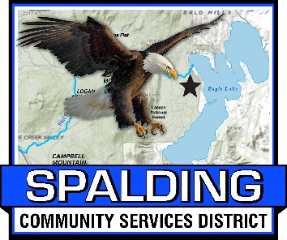**BOARD OF DIRECTORS**

**MEETING AGENDA**

**MEMBERS OF THE BOARD**

Ted Thomas, Board Chair

Ed Lawson, Board Vice Chair

Randy Aubrey, Director

Larry Doss, Director

Vacant, Director

**February 16, 2024**

**3:00 PM**

**Meeting Location**

**Eagle Lake Community Center**

**502-907 Mahogany Way, Susanville, CA 96130**

**530-825-3258**

**Welcome to the SCSD Board Meeting - Please sign in**

1. CALL TO ORDER
2. ROLL CALL

____ Ted Thomas ____ Randy Aubrey ____ Larry Doss

____ Ed Lawson ____ (Vacant)

1. PLEDGE OF ALLEGIANCE
2. APPROVAL OF THE AGENDA
3. PUBLIC COMMENT - Members of the public may provide public comment on any item on the Board’s agenda, or on any item that is within the subject matter jurisdiction of this Board. Public comments are limited to five (5) minutes (unless the Chairman of the Board grants a longer period of time). Comments by members of the public on an item that appears on the agenda will only be allowed during consideration of the item by the Board.
4. APPROVAL OF MINUTES
   1. Submitted for approval are the minutes from the January 19, 2024 Board Meeting.
5. FIRE CHIEF REPORT TO BOARD
   1. There were 3 calls in January: 1 medical call, 1 Auto Accident/Roll over, 1 Fire call-burning debris- given a warning

* 1. We had two 2.5 hour training sessions in January:

2.5 hr. Vehicle Lift Bag training/review, 2.5 hr. Vehicle maintenance

1. GENERAL MANAGER REPORT TO BOARD
   1. District Financials
2. SEWER REPORT

See Attached Report

1. BOARD MEMBER REPORTS / BOARD MEMBER COMMENTS
2. NEW BUSINESS
   1. Resolution 2024-02: Board of Directors Meetings
   2. Board Discussion – Marina Parking Lot for Camping, Amending Ordinance #4 Sections 4.01.050 and 4.01.080
3. CONTINUING BUSINESS
   1. Board Discussion on Suggestions/Implementation of District Projects for Board Members and the Development of Committees
4. ADJOURN

The Next Board Meeting will be on March 15, 2024

All documents available for public review are on file at the District's office located at 502- 907 Mahogany Way, Susanville, CA 96130

Any person with a disability who requires accommodations in order to participate in this meeting or for package materials in an alternative format should telephone the District at 530-825-3258, at least 48 hours prior to the meeting in order to make a request for a disability-related modification or accommodation. All accommodation requests will be handled swiftly and resolving all doubts in favor of access. Copies of records provided to Board Members which relate to any agenda item to be discussed in open session may be obtained from the District at 502- 907 Mahogany Way, Susanville, CA 96130.