SPALDING COMMUNITY SERVICES DISTRICT
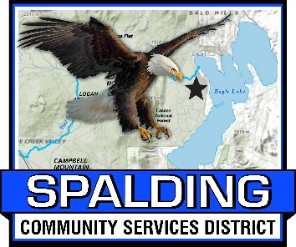
BOARD OF DIRECTORS
Members of the Board
Mike Arnold, Board Chair
Larry Doss, Board Vice Chair
Randall Aubrey, Director
Ed Lawson, Director
Ted Thomas, Director

MEETING AGENDA
June 16, 2023
3:00 PM
Meeting Location
Eagle Lake Community Center
502-907 Mahogany Way, Susanville, CA 96130
530-825-3258
www.Spaldingcsd.org

Welcome to the SCSD Board Meeting - Please sign in

Welcome to the SCSD Board Meeting! Members of the public may provide public comment on any item on the Board’s agenda, or on any item that is within the subject matter jurisdiction of this Board. Public comments are limited to five (5) minutes (unless the Chairman of the Board grants a longer period of time).

CALL TO ORDER
ROLL CALL
____ Mike Arnold ____ Randy Aubrey ____ Larry Doss
____ Ed Lawson ____ Ted Thomas

- PLEDGE OF ALLEGIANCE

- PUBLIC COMMENT - Members of the public may provide public comment on any item on the Board’s agenda, or on any item that is within the subject matter jurisdiction of this Board. Public comments are limited to five (5) minutes (unless the Chairman of the Board grants a longer period of time).

- APPROVAL OF THE AGENDA

- APPROVAL OF MINUTES

- Submitted for approval are the minutes from May 19, 2022 Board of Directors Meeting

- FIRE CHIEF REPORT TO BOARD

- The Fire Department went on 2 calls in May; Volunteers continued with their training.
- The Fire Department was recognized with a certificate of appreciation from Nor-Cal EMS.
- SEMSA and CalFire helicopters will be coming up to the District for Volunteer training on how to work around helicopter transport.
- REMINDER: There will be a Independence Day Weekend Pancake Breakfast on Sunday, July 2nd from 7:00am to 11:00am. The Memorial Day Weekend Pancake Breakfast was very successful; 135 people showed up for breakfast!!

- GENERAL MANAGER REPORT TO BOARD

  - Staff Report on Property at Marina
  - Staff Report on Lahontan meeting for Marina
  - May, 2023 Financial Reports

- SEWER DEPARTMENT REPORT

  - See attached report

- BOARD MEMBER REPORTS / BOARD MEMBER COMMENTS

- CONTINUING BUSINESS

  - SCSD Sewer Rate Study from NorthStar – No new business.

- NEW BUSINESS

  - Resolution 2023-006 – Resolution Amending Policy 5060 Providing For The Removal Of The Requirement For District Audio Tape Recordings.

- ADJOURN

Next Regular Board Meeting is scheduled for July 21, 2023 AT 3:00 PM

